
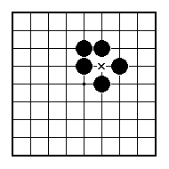
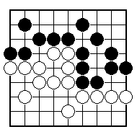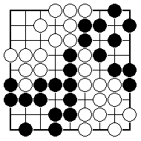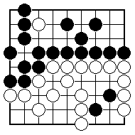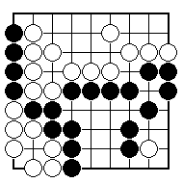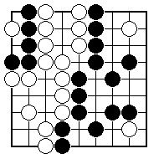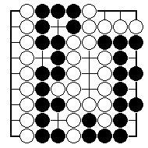
Which are the neutral points?

Where are all the neutral points? How many are there?

Which stones are dead?

Which stones are dead?

Which stones are dead?

Which stones are dead?

NAME:
BRITISH GO ASSOCIATION CERTIFICATE LEVEL 2 - SHEET 3

NEUTRAL POINTS AND DEAD STONES

